CS532 Homework 11

Archana Machireddy

Question 1

T = 1583832647

P = 83832

Using Horner’r rule

p = P[m] + 10(P[m-1] +10(P[m-2] + … + 10(P[2] +10P[1])))))

p = 2 + 10(3 +10(8 +10(3 + 10*8)))

= 2 + 10(3 +10(8 +10(83)))

= 2 + 10(3 +10(838))

= 2 + 10(8383)

= 83832

to = 8 + 10(3 +10(8 +10(5 + 10*1)))

= 8 + 10(3 +10(8 +10(15)))

= 8 + 10(3 +10(158))

= 8 + 10(1583)

= 15838

ts+1 = 10(ts – 10m-1 T[s+1]) + T[s+m+1]

t1 = 10(t0 -105-1T[1]) + T[6]

= 10 (15838 – 10000*1) + 3

= 58380 + 3

= 58383

t2 = 10(t1 -105-1T[2]) + T[7]

= 10 (58383 – 10000*5) + 2

= 83830 + 2

= 83832

T3 = 10(t2 -105-1T[3]) + T[8]

= 10 (83832 – 10000*8) + 6

= 38320 + 6

= 38326

Question 2

216 = 65536. Storing numbers from 0, largest number that can be stored is 65535.

The largest value of q is 6553.

Question 3

Question 4

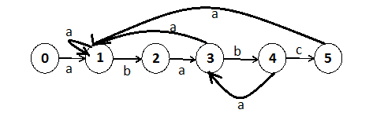

Question 5

|  |  |
| --- | --- |
|  | Prefix |
| P0 | ε |
| P1 | a |
| P2 | ab |
| P3 | aba |
| P4 | abab |
| P5 | ababc |

Question 6

|  |  |  |  |  |  |  |  |
| --- | --- | --- | --- | --- | --- | --- | --- |
| i | Pi | Next Character | | | | | |
| a | | b | | c | |
| String | Longest Prefix | String | Longest Prefix | String | Longest Prefix |
| 0 | ε | εa | 1 | εb | 0 | εc | 0 |
| 1 | a | aa | 1 | ab | 2 | ac | 0 |
| 2 | ab | aba | 3 | abb | 0 | abc | 0 |
| 3 | aba | abaa | 1 | abab | 4 | abac | 0 |
| 4 | abab | ababa | 3 | ababb | 0 | ababc | 5 |
| P | ababc | ababca | 1 | ababcb | 0 | ababcc | 0 |